**Дата**: 6.12.2024

**Клас**: 5-А

**Предмет**: англійська мова

**Тема:** Національні свята в різних країнах .

**Мета:** : формувати навички вживання лексичних одиниць по темі; удосконалювати навички читання, аудіювання й усного монологічного мовлення; розвивати пізнавальні інтереси учнів; виховувати інтерес до самостійного пошуку потрібної інформації, а також загальну культуру учнів.

**Вчитель**: Руда Д.В.

Хід уроку

1.Greeting

Good afternoon, guys! I’m glad to see you. Are you ready to start our lesson? All set?

2. Wаrm up / Listening

Уважно слухати аудіо трек і дати відповідь на питання вчителя <https://www.youtube.com/watch?v=AE6_Be1H1cM&t=33s> .

3. Speaking

Дати усно відповіді на питання :

How many holidays do you have in your country?

What special foods are associated with your favorite holiday?

What special clothing/customs are associated with your favorite holiday?

What is your favorite holiday memory? Tell us about it.

Who is your favorite holiday character (e.g. Santa Claus)? Why?

What are three holidays that you like to spend with your family?

What is your worst holiday memory? Tell us about it.

If you had a long holiday, what will you do with it?

Do you like to stay up late on holidays?

Who do you usually spend the holidays with?

If a holiday falls on a Sunday, should you get another day off?

What is best present you ever received?

What is your favorite holiday food?

What is your favorite holiday song?

Does it bother you that some holidays are religious and some are not?

Do you celebrate holidays differently now than you did when you were a child?

What is your favorite holiday festival in your country?

Do you light off fireworks on New Years Eve in your country?

If you could visit any other country during Christmas, where would you go?

What holiday is the most dangerous in your country?

What holiday is the most exciting in your country?

4. Повторення

Повторити past simple.

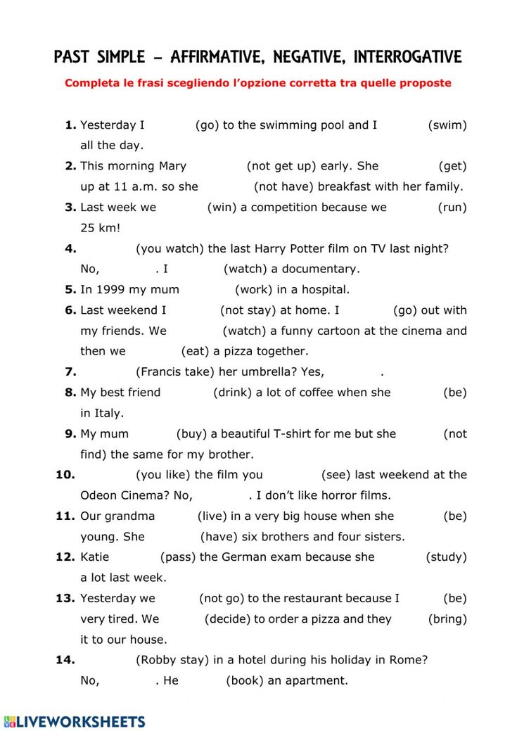

5. Writing

Виконати письмово вправу 1, 2, 3 стр 60.

6. Homework

1. Виконати вправу 4,5 стр 60.